Does real-time transit information reduce waiting time? An empirical analysis

Luyu Liua,b and Harvey J. Millera,b,*[1]

a Department of Geography, Ohio State University, Columbus, Ohio, USA;

b Center for Urban and Regional Analysis, Ohio State University, Columbus, Ohio, USA.

**Abstract:**

A claimed benefit of real-time information (RTI) apps in public transit systems is the reduction of waiting times by allowing passengers to appropriately time their arrivals at transit stops. Although previous research investigated the overall impact of RTI on waiting time, few studies examine the mechanisms underlying these claims, and variations in its effectiveness over time and space. In this paper, we theorize and validate the sources of RTI-based users’ waiting time penalties: *reclaimed delay* (bus drivers compensating for being behind schedule) and *discontinuity delay* (an artifact of the update frequency of RTI). We introduce five trip planning strategies (TPSs) that cover possible behaviors that ignore or use RTI in deciding when to depart home to arrive at a nearby transit stop. Using real-time bus location data from a medium-sized US city, we calculate the realized waiting times and risk of missing a bus for each TPS. We find that the best RTI strategy, a prudent tactic with an optimized insurance time buffer, performs roughly the same as a simple, follow-the-schedule tactic that does not use RTI. However, relative performance varies over time and space. Moreover, the greedy tactic of using RTI to achieve a waiting time of zero is the worst strategy, even worse than showing up at a bus stop arbitrarily. These results suggest limitations on claims that RTI reduces public transit waiting times.

**Keywords:** Public transit; Real-time information; Mobile apps.

1. **Introduction**

Capabilities for collecting and sharing real-time information about transportation systems is changing how people navigate and travel through cities. Apps and services such as Google Traffic, INRIX and Waze provide departure time and route suggestions for automobile-based travel based on current and predicted traffic and travel times, allowing users to avoid traffic congestion, minimize travel time and arrive on-time more frequently (Cabannes et al. 2018). Correspondingly, many public transit agencies are sharing schedule and real-time vehicle location data to enable navigation apps that make public transit more convivial and useful to users.

Public transit navigation apps allow users to discover and navigate public transit systems with complex routes and schedules (Dutzik, Madsen, and Baxandall 2013). Public transit apps often provide real-time information (RTI) on vehicle locations and arrival times to make the system feel more convivial to users. RTI can help users reduce the amount of time they must wait for public transit at stops; this is crucial since waiting time is perceived as onerous by users and cited as a major reason why people do not like using public transit (Algers, Hansen, and Tegner 1975; Fan, Guthrie, and Levinson 2016; Gkioulou 2013; Larsen and Sunde 2008; Reed 1995). The rationale behind the saved waiting time is that RTI allows users to determine the best time to leave their home, workplace or similar location to travel (typically, by walking) to a public stop. RTI users can access frequently updated data on bus location and arrival times at stops, adjusting their departure time accordingly (Brakewood et al. 2015; Brakewood, Barbeau, and Watkins 2014; Cats and Gkioulou 2017; Ferris, Watkins, and Borning 2010; Papangelis et al. 2016; Watkins et al. 2011).

RTI can be especially important for systems with sparser timetable and longer headways such as those in medium and smaller urban areas. As Walker (2012) argues, with public transit, frequency is freedom, but frequency is expensive. In public transit systems that cannot sustain high frequency service due to limited resources, RTI can play an important role as a substitute to allow users to experience short waiting times despite infrequent service. RTI may be especially critical to users due to time penalties associated with missing a bus on route with long headways.

Ideally, RTI apps can diminish waiting time to zero, which means as soon as a user arrives at a stop, the bus arrives. However, this attempted minimization of wait time by users can be risky. After a person decides to leave their home, the actual arrival time of the bus may change. If a bus is behind schedule, the operator may take opportunities to reduce the delay by speeding up. In addition, RTI apps update vehicle location and arrival times only at fixed time intervals (e.g. every minute). The discrepancies between the RTI and reality means that a user may miss the bus, resulting in long wait time – at least as long as the service headway; longer if the bus schedule has larger headway. Paradoxically, the use of RTI may increase waiting times based on the realized performance of the public transit system.

In this paper, we examine the impacts of RTI on public transit users’ waiting time based on the empirical performance of a public transit system. We compare several trip planning strategies for deciding when to leave home to travel to the designated stop, including strategies that ignore and exploit RTI. We compare the performance of these strategies using high-resolution schedule and real-time vehicle location data for a popular bus route operated by the Central Ohio Transit Authority (COTA) in Columbus, Ohio, USA. We find that the best RTI strategy, a prudent tactic with an optimized insurance time buffer, performs roughly the same as a simple, follow-the-schedule tactic that does not use RTI. However, relative performance varies depending on time of day, distance to the bus stop, and the location of the stop along the bus route. Although RTI can have other benefits (such as reassuring users), these results suggest limitations on the value of RTI in reducing user wait time

In the next section of this paper, we will review previous research about the impact of RTI on transit users’ waiting times. The subsequent section introduces our data sources, a theory of the mechanisms that underlie RTI users’ waiting time penalties, and five types of trip planning strategies that either ignore or exploit RTI. We demonstrate each TPS’ overall performance and performance with respect to time, distance to bus stop, and location of the bus stop within the route. We also verify our theory of the mechanisms underlying the time penalties experienced by RTI users. We conclude this paper with a discussion of major findings, their significance for science and planning, and potential next research steps.

1. **Literature review**

In this section, we provide a comprehensive review on studies about the impact of mobile real-time information. The development and deployment of global positioning system receivers and other automated vehicle location system, open data policies by transit authorities, and the widespread adoption of the World Wide Web mobile telephony has generated a widespread use of RTI by public transit agencies and users. Correspondingly, the body of literature on RTI in public transit is growing and there are numerous studies investigating real-time information’s impact on public transit users. In this review, we will first review the methods of quantifying the impacts of RTI on waiting time and report these studies’ findings.

* 1. **Methods**

Survey-based methods is the most common among RTI impact studies. These methods include on-board surveys (Fan, Guthrie, and Levinson 2016), before-after surveys (Chow, Block-Schachter, and Hickey 2014), web-based surveys (Ferris, Watkins, and Borning 2010), in-person surveys (Watkins et al. 2011), interviews and observations (Papangelis et al. 2016), and stated preference surveys (Y. Liu, Shi, and Jian 2017). These methods can moreover be classified into two categories: self-reported survey and observation. Self-reported surveys are the most direct methods to assess transit system use and especially useful to measure user experience and perceptions. Survey data can also help assess individual differences based on gender, demographic and social attributes (Neuman, W. L., & Robson 2004).

However, despite extremely useful under the mentioned circumstances, self-reported survey can be inaccurate since they are based on perceived or self-reported waiting time instead of actual waiting time (Brakewood, Barbeau, and Watkins 2014; Mishalani, McCord, and Wirtz 2006). Observation survey by a third-party researcher or a censor can better measure the actual waiting time. For example, in Seattle, RTI users’ self-reported average perceived waiting time were 7.54 minutes compared to non-RTI users’ 9.86 minutes, while the average actual waiting time obtained by observers for RTI users is 9.23 minutes compared to non-RTI users’ 11.21 minutes (Watkins et al. 2011).

Another approach to analyzing the impacts of RTI on waiting times is mathematical simulation. Agent-based modeling represents the simultaneous actions and interactions of various agents in intricate and complicated systems such as public transit (Gkioulou 2013). For example, Cats & Gkioulou (2017) adopted an agent-based model to simulate the influence of transit reliability and real-time information on waiting time uncertainty.

* 1. **Findings**

Numerous studies investigated RTI’s impact on public transit users and drawn different conclusions on the effectiveness of RTI for different region and different RTI media. In this section, we will focus on impact of personal devices RTI and summarize prior quantitative findings.

Most studies reported that RTI can reduce *perceived waiting time* by using self-reported surveys. Ferris, Watkins, and Borning (2010) concluded that 91% of RTI users spent less time waiting in Seattle. Brakewood, Barbeau, and Watkins (2014) conducted behavioral experiment in Tampa to test the self-reported waiting time and found that RTI user reported 1.5 minutes less than the control group. Similar conclusions were drawn in other contexts besides urban transit systems for commuting. Papangelis et al. (2016) found an average self-reported waiting time reduction of 7 minutes in rural Scotland. Y. Liu, Shi, and Jian (2017) presented that tourists’ perceived waiting time became longer without RTI. Some studies also concluded that RTI has positive impact on the *actual waiting time* by observation. Watkins et al. (2011) found that RTI users can save 2 minutes than non-RTI users while the perceived waiting time reduced 2.4 minutes in Seattle.

However, some studies also concluded that RTI has limited impact on both perceived and actual waiting time in some cities. Brakewood et al. (2015) explored the impact of mobile platform RTI on Boston commuter rail services and concluded that perceived waiting time did not have a statistically significant difference between RTI and non-RTI users on the survey days. Fries, Dunning, and Chowdhury (2011) used video feed to construct simulation model of waiting time and found pre-trip travel time savings, which is part of actual wait time, were small; the major benefit of RTI is anxiety reduction.

Although the overall impact of RTI on waiting time is well-explored, few studies investigate the variance of these impacts (Brakewood and Watkins 2019). Most studies focus on the overall average actual waiting time or perceived waiting time; however, no one has investigated the variance of this impact relative to transit system’s actual on-time performance. Empirical performance matters because on-time performance and delays can be heterogeneous within a system and even within a single route (Park et al. 2019). In addition, a key decision of public transit users is when to leave their home (or other origin) to travel to a stop; therefore, the impact of RTI on waiting times may vary with walking time to the stop. Due to the heterogeneity of on-time performance, the impact of RTI may also vary by the location of the stop within a route. This paper fills this research gap by analyzing the overall and disaggregate performance of different trip planning strategies that both ignore and exploit transit RTI based on the actual performance of a public transit system.

1. **Methodology**

In this section, we introduce our data sources. Next, we conceptualize catching a bus as a synchronization process between the user and the vehicle, and introduce the concepts of *reclaimed delay* and *discontinuity delay*: the former related to over-estimation of bus arrival time, the later related to the RTI updating frequency. Both can have impacts on RTI users. Based on the synchronization theory, we propose and model several trip planning strategies (TPSs) representing the possible behaviors of users. We also optimize the RTI apps user’s strategy based on real-time data; this represents an ideal RTI app that provides pro-active advice to users. We also calculate the waiting time difference between RTI apps users’ deterministic process and non-RTI users’ probabilistic process.

* 1. **Data**

We use two data sources to represent two major actors in a public transit system: General Transit Feed Specification (GTFS) real-time data corresponding to the information available to users and automated passenger count data to represent the actual on-time performance behavior of the transit system.

General Transit Feed Specification (GTFS) real-time provides a homogeneous protocol to effectively transmit transit real-time information with normalized standard. As a result, most RTI apps will use the estimated arrival time provided by GTFS trip update for the buses’ real-time information (Google Developers 2018; Transit app 2019). Therefore, we can simulate RTI users’ behavior from the GTFS trip update data.

Nevertheless, although GTFS data’s resolution is relatively high, its *temporal accuracy* is not satisfying. Similar to Firmani et al. (2016)’s definition, we define temporal accuracy as: how accurate is the measure’s recorded time compared to the actual time. It represents the systematic error caused by the temporal delay of measurement. GTFS data is updated based on a fixed interval; this could range from 5 seconds to 2 minutes depending on the system. Consequently, the reported times of bus arrivals at stops could be different from the actual arrival times.

To solve the temporal accuracy issue, we used an administrative data source: Automatic Passenger Counting (APC) data. The APC data is collected by the passenger counters installed on each bus, which is primarily intended to summary the ridership. Moreover, the data also contains the accurate arrival/departure time recorded promptly at each stop. Compared with GTFS, it is more appropriate to use APC to calculate the system performance and RTI-based users’ actual performance. However, because the APC devices are not available for every bus, its system coverage is not 100% unlike GTFS. Correspondingly, to make the APC data possible to sustain the calculation, we will merge the APC data and GTFS to achieve both higher temporal accuracy and 100% system coverage: for every GTFS real-time record, query the corresponding trip and stop in the APC database and overwrite if exists.

For the development and implementation of our methods, we selected Columbus, Ohio and Central Ohio Transit Authority (COTA) as the site for the case study. First, COTA bus system’s average headways are considerably large, which makes the waiting time a significant factor when actually using the system; second, as a typical car-oriented American city, the case study can be easily expanded to other cities and larger scales with same data support and methodologies. We collected and organized the GTFS schedule data in MongoDB and Python environment from Application Programming Interface (API) provided by COTA from May 2018 to May 2019; for GTFS real-time, we archived the streamed data with frequency of 1 minute for the same time period. We also received the APC data from COTA from May 2018 to May 2019.

* 1. **Synchronization**

We conceptualize catching a bus as a synchronization process between the walking trip to the target stop and the target bus’s *trip sequence array*. Trip sequence array is defined as the collection of trips running on the same route and in the same direction as the target bus.

Depending on user’s arrival time at the stop *t*, the actual bus that user will take can be different from the scheduled one. We use the same concept in the transfer synchronization process: *desynchronization degree* (DD), to measure the desynchronization between the bus and user at the stop (L. Liu and Miller 2019). DD is an integer indicator that represent how many buses the user loses in the trip sequence array:

|  |  |  |
| --- | --- | --- |
|  | $$\begin{aligned}DD=\left\{\begin{aligned}0, \text{if actual bus is scheduled bus} \\ n, \text{if actual bus is }{\text{n}}_{\text{th}}\text{ after scheduled bus in the sequence array} \\ -n,\text{ if actual bus is }{\text{n}}_{\text{th}}\text{ before scheduled bus in the sequence array}\end{aligned}\right. \#\#\#\#\#\#\#\end{aligned}$$ | (1) |

It also means that if the user arrives at the stop between bus DD = n – 1 and bus DD = n, then the user will take bus DD = n.

When synchronizing, the process of walking is linear: the users can control the walking time by selecting their home departure time (HDT). Except for very crowded conditions in dense cities, we can assume walking time is linear with respect to distance. In contrast, the actual real-time performance of the bus is non-linear: the bus will not run at a fixed velocity and the expected time of arrival of bus at the stop is constantly changing. The vehicle operator can change the vehicle’s speed based on conditions in real-time. Most relevant to our question, a vehicle operator can make up for an initial delay by increasing speed. Indeed, public transit agencies value on-time performance and may incentivize drivers to compensate for delays when possible, considering speed limits and safety considerations.

We therefore introduce the concept of *reclaimed delay (RD).* Similar to delay propagation (Park et al. 2019), it is the time difference between the actual time of departure and the expected time of departure at the stop.

Figure 1 shows corresponding space-time diagram of the expected synchronization, the actual desynchronization, and delay reclamation process. After the user leaves home, the actual bus trip (blue line) will diverge from the expected bus trip (red line) and converge with the scheduled bus trip (yellow line): since the bus has an initial delay near the user’s home, the bus accelerates and catches up the delay with the schedule. However, the user’s walking trip is still aiming for the expected bus trip. Consequently, the bus arrives earlier than the user’s expected time and the user will miss the bus.

The reclaimed delay could be small but critical for RTI apps users: consequently, the RTI apps user will miss the bus and suffer waiting time penalty for a relatively long time. Thus, the synchronization of these two processes is highly unstable. Besides the delay reclamation mechanism, other RTI-related factors such as inaccurate geographic locations and delays in updates due to internet congestion and failures may also contribute to the desynchronization.

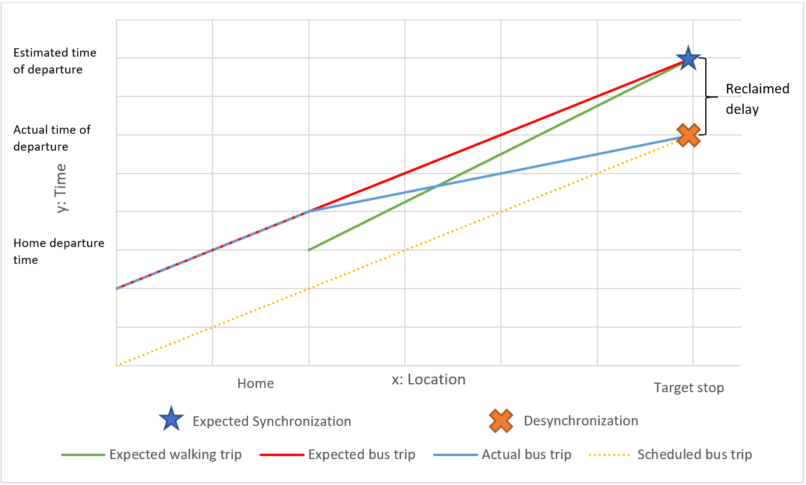

Figure 1: space-time diagram of the expected synchronization and the actual desynchronization.

Besides reclaimed delay, due to the discrete nature of the GTFS real-time data, there are a *discontinuity delay* for all RTI-based trip planning strategies as shown in Figure 2: if RTI apps do not interpolate the void between the data feeds and their corresponding timestamp, the RTI-based users will wait until the data is updated. However, when the data is updated, the RTI-based user may already be late for the bus. Similarly, if the user decides to leave between two updates, although the RTI apps will show a good result based on the last update, in reality the user will miss the bus. Either scenario is the consequence of discontinuity of the real-time data. Exactly like reclaimed delay, although the discontinuity delay could be very small in value, it still can result in desynchronization and significantly long waiting time. Both reclaimed delay and discontinuity delay produce potential missed risk for RTI-based users.

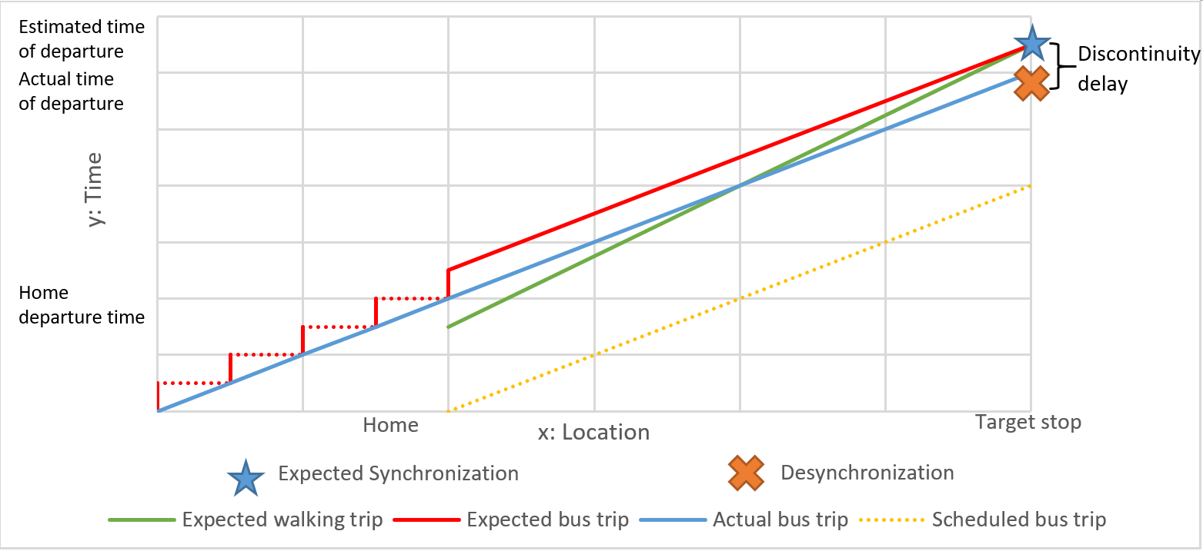

Figure 2: the discontinuity delay of real-time data.

* 1. **Trip planning strategies**

A trip planning strategy can be interpreted as a tactic for a user to plan and execute a transit trip. There are different trip planning strategies for both RTI apps and non-RTI users to determine their HDT. Table 1 summarizes the strategies we explore in this study; we elaborate these below.

|  |  |
| --- | --- |
| **Non-RTI trip planning strategy** | **RTI-based trip planning strategy** |
| Arbitrary tactic (AT) | Greedy tactic (GT) |
| Scheduled tactic (ST) | Prudent tactic (PT) |
| Empirical tactic (ET) |  |

Table 1: Non-RTI and RTI-based trip planning strategies.

Assuming no disturbance on user’s walking and boarding process, different trip planning strategies have only one controllable factor to determine the actual waiting time, namely, the home departure time:

|  |  |  |
| --- | --- | --- |
|  | $$δt=T\left(t_{a}\right)-t_{a}=T\left(t+δt_{w}\right)-t-δt_{w}$$ | (2) |

Where ta is the passenger’s arrival time at the stop, t is the home departure time, δtw is the walking time, and T(ta) is the corresponding bus boarding time which depends on when the passenger arrives at the stop. Therefore, in the following sections, we will define each trip planning strategy by giving the formula of either its actual waiting time or its home departure time.

* + 1. Arbitrary tactic (AT)

The simplest strategy is to arbitrarily walk to a stop and catch the subsequent bus that arrives. Because the user’s decision-making process is random, it is reasonable to assume user’s HDT or user’s arrival time is evenly distributed among the headway between two buses. Since we have access to the real-time vehicle departure time data, we can directly calculate the waiting time as the median of the departure time of target bus and its subsequent bus without calculating the HDT:

|  |  |  |
| --- | --- | --- |
|  | $$δt=\frac{1}{2}⋅(T-T')$$ | (3) |

Where: δt is waiting time, $T$ is the bus’s actual real-time departure time, and $T'$ is the previous bus’s actual real-time departure time with desynchronization degree = -1.

Theoretically, this strategy is not very efficient since it is always the half of the buses’ actual headway. Therefore, it is a good benchmark for other TPS: if another TPS performance is even worse than AT, we can assert that it is not effective.

* + 1. Scheduled tactic (ST)

These timetable-dependent users make their HDT decisions based on the schedule published to the public:

|  |  |  |
| --- | --- | --- |
|  | $$t=T^{*}-δt_{w}$$ | (4) |

Where: *δtw* is the walking time from user’s home to the stop, *T\** is the scheduled bus departure time.

ST users do not benefit from waiting time reduction based on RTI. However, since COTA bus will rarely if ever leave a stop earlier than the scheduled time due to timetable policy (COTA 2019), ST minimizes the missing risk. ST is another benchmark for all TPSs, which theoretically has the lowest risk of missing a bus.

* + 1. Empirical tactic (ET)

This TPS is based on a user's personal experience with the transit system. The ET is based on a learning function and memory. The learning function refers to the property derived from an empirical experience, such as average or minimum wait times; memory is the number of observations comprising the user experience or, equivalently, the number of recent observations recalled by the user:

|  |  |  |
| --- | --- | --- |
|  | $$t=\overline{T}-δt_{w}=\min_{n}{T_{i}}-δt_{w}$$ | (9) |

where: $\overline{T}$ is the user’s empirical arrival time at the bus trip $.$ $T_{i}$ is the bus trip’s actual departure time on day *i*, and n is the learning memory. This is an idealistic, upper limit: the learning function can also have parameters reflecting learning rates and recall veracity.

Figure 3 visualizes results from our data based on two learning functions (averaging and minimum wait times) with memory ranging 1 - 9. Note that average waiting time increases with longer memory with averaging learning function. Learning the average wait time is a poor strategy due to the sudden jump in time penalty associated with missing a bus. In contrast, learning the minimum wait time is a more effective strategy that tends to improve with longer memory, although this improvement is volatile due to the volatility of that empirical parameter. In the analysis presented later in this paper, we use an ET based in minimal wait times with memory = 6.

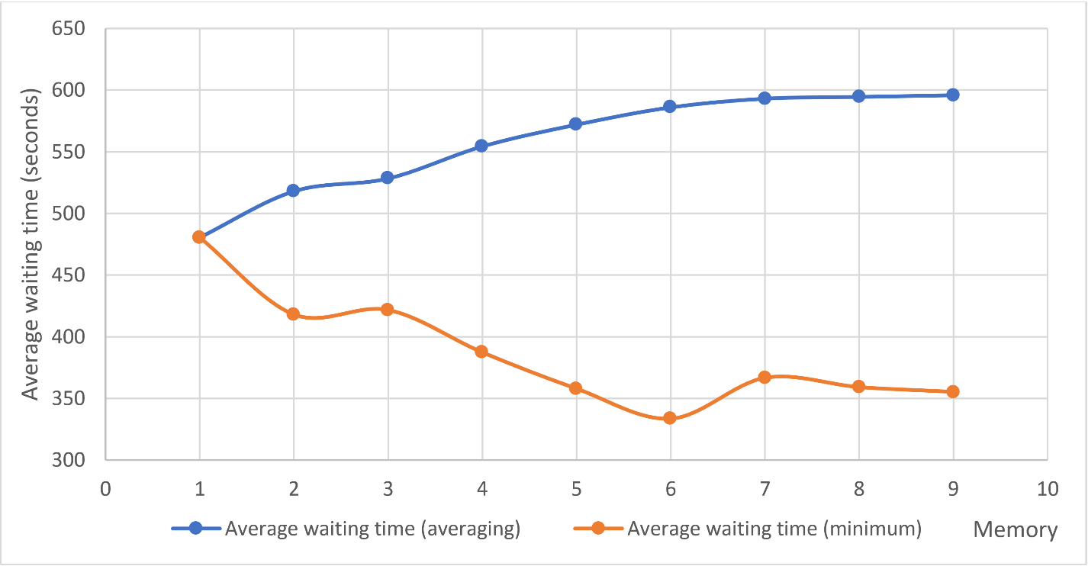

Figure : the waiting time of ET family with minimum and averaging learning function and 1 – 9 learning memories.

* + 1. Greedy tactic (GT)

Greedy tactic is a very common strategy used by different transit planning apps, for GTFS’s na

The greedy tactic (GT) and prudent tactic (PT) (discussed below) both exploit RTI. A GT user will use an RTI app to check the relationship between suggested ETD and current time, only leaving home when the bus’s ETD at the stop is equal to or greater than walking time plus current time:

|  |  |  |
| --- | --- | --- |
|  | $$t_{hd}=t_{cu}, if t_{cu}+δt_{w}≥T_{ex}$$ | (10) |

Where: $T_{ex}$ is the scheduled bus’s ETD at the stop given by RTI app and real-time data, and $t_{cu}$ is the current time when $t_{cu}+δt_{w}≥T_{ex}$.

This strategy can achieve a minimal wait time as shown in Figure 1 (green line). However, due to the instability of transit system, a GT’s risk of missing a bus is also the highest. Due to the possible reclaimed delay and discontinuity delay, the bus may leave the stop earlier than the ETD. Consequently, the user may suffer from a long waiting time penalty, which is almost equal to a headway, the largest possible waiting time.

* + 1. Prudent tactic (PT)

To manage the risk of missing a bus, a RTI user may want leave home earlier than the GT. This is a common strategy to avoid risk of missing a bus (Fonzone, Schmöcker, & Liu, 2015; Frumin & Zhao, 2012). An *insurance buffer*, trades some time to reduce risk of missing a bus. Given a user-designated IB, the HDT is:

|  |  |  |
| --- | --- | --- |
|  | $$t_{hd}=t_{cu}, if t_{cu}+δt_{w}+IB≥T_{ex}$$ | (11) |

An IB value is an indicator of the transit users’ risk attitude: it represents how much time the user is willing to gamble to gain the waiting time reduction. We define two extreme values of risk attitude: *risk-seeking* and *risk-averse*. *Risk-seeking* means the user would rather seek for the waiting time reduction regardless of the potential missed risk, which will possibly incur an additional large waiting time caused by desynchronization; *risk-averse* means the user would rather wait more time to avoid desynchronization. The less IB’s value is, the more risk-seeking and less risk-averse the user.

We can consider PT and GT as part of a *prudent tactic family*, for GT is a special case of PT with IB = 0. With different IBs, each prudent tactic can vary in actual waiting time. However, we can optimize IBs and find the best prudent tactic with minimal wait time based on system performance.

Figure 4 shows how a PT strategy with optimal IB can resynchronize with the actual bus trip. Instead of the expected walking trip (shown as green solid line), the PT optimal user will follow the RTI apps’ pre-calculated optimal plan with insurance buffer (shown as green dash line). Due to the existence of insurance buffer, the reclaimed delay is therefore offset and the user will successfully take the expected bus.



Figure : Space-time diagram of a PT trip.

For PT or GT, the users will plan their HDT according to the bus’s ETD instead of the real departure time. Here we define expected waiting time:

|  |  |  |
| --- | --- | --- |
|  | $$δt^{'}=T_{ex}\left(t\right)-t=T_{ex}\left(t\right)-t_{hd}^{PR}-δt_{w}$$ | (12) |

where: $T_{ex}\left(t\right)$ is the ETD, t is the user’s arrival time at the stop, $t_{hd}^{PR}$ is PT strategy’s HDT, and $δt_{w}$ is the walking time. Combining Equation (11) and Equation (12), we have: $IB≥δt^{'}$. For PT family, insurance buffer should be at least equal to the expected waiting time.

To find the optimal PT empirically, we simulate the users’ real-time waiting time based on the transit systems empirical performance using different IB. There are four major steps in the process:

* Calculation: Designate a set of IBs (e.g., 0 – 300 seconds) and walking time ranges (e.g., 0 – 9 minutes). Calculate the performance for all designated buffers. The results contain user’s arrival time at the stop and the actual taken bus’s departure time for users with different walking time
* Optimization: Find the smallest waiting time and the corresponding buffer each day. If there are multiple smallest waiting time, designate the one with smaller buffer.
* Finalization: For each day, reduce all past days’ buffers into one by finding the maximum of the optimal buffers. To accommodate changes in the schedule, we will restart the process whenever a change is implemented.
* Revalidation: Based on the finalized buffers, calculate the performance of each day.

The *calculation step* and *optimization step* guarantee that obtained buffers in each day have the least waiting time. The *optimization step* guarantees that obtained buffers are the smallest one among the buffers with the least waiting time. The *finalization step* guarantees that trips with finalized buffers are most synchronized for each day when revalidating the performance. In the sense of risk attitude, this is a *risk-neutral* strategy: we want to find the smallest buffers while trying to keep synchronized for most trips.

However, the number of insurance buffers is large: we minimize waiting time over each $IB_{ijk}$, which represents a different IB for each trip $i$, each stop $j$, and each walking time $k$ from the stop (0 – 10 min). The computational burden is consequently large: the worst case is polynomial but high power. To improve the computational performance, we parallelized the outmost loops (buffers × dates) on a workstation with 40 virtual CPU cores. Nevertheless, in our study, the collected transit system data volume for the period May 2018 to May 2019 is terabyte-scale; correspondingly, the computational burden to calculate all of the bus routes is considerably large. Therefore, we selected a representative bus route to study.

1. **Analysis**

In this section, we focus on the performance of different TPS based on empirical schedule and actual bus arrivals at stops along one bus route in the Columbus, Ohio, USA Central Ohio Transit Authority (COTA) system: route No. 2. We chose this route for its popularity (it is the one of the busiest routes in the system) and coverage (it traverses a long spatial transect of the city and has a long service temporal span). Figure 6 provides a map of COTA bus No. 2 from Southeast to Northwest during the period May 2018 to May 2019. The bus route has two schedules: the frequent schedule originates from the red circled stop in Figure 6 with headways of 10 – 15 minutes, while the standard (non-frequent) schedule originates from blue circled stop with headways of 20 – 30 minutes (COTA 2013).



Figure : Bus route 2's standard and frequent service map (COTA 2013).

* 1. **TPS overall performance**

Table 2 shows themean and deviation of each TPS waiting time and risk of missing a bus. Overall, strictly following the schedule (ST) or using RTI to determine an optimal insurance buffer (PT) are the best strategies: these achieve roughly equivalent waiting time performance based on waiting time average and standard deviation; they also have similar performance based on bus missed risk average and standard deviation. Ignoring RTI and learning the minimal waiting time based on experience (ET) is the next best strategy based on overall performance, followed by showing up at the bus stop at an arbitrary time (AT). (For AT, because we do not simulate and validate the decision-making process like the other TPSs; instead, we directly calculate the average waiting time using Equation (7).)

|  |  |  |  |  |  |
| --- | --- | --- | --- | --- | --- |
| Strategy class | Trip planning strategy | Waiting time | | Risk of missing bus | |
| Mean | Standard deviation | Mean | Standard deviation |
| No real-time information | Arbitrary Tactic (AT) | 510 seconds | - | - | - |
| Schedule Tactic (ST) | 252 seconds | 345 seconds | 6.28% | 16.55% |
| Empirical Tactic (ET) | 334 seconds | 494 seconds | 18.39% | 38.74% |
| Real-time information | Greedy Tactic (GT) | 751 seconds | 707 seconds | 74.63% | 74.50% |
| Prudent Tactic (PT) | 282 seconds | 381 seconds | 10.18% | 17.70% |

Table : Overall performance of TPS; waiting time and missed risk's mean and deviation.

The worse strategy is the greedy one (GT) that tries to exploit RTI to achieve a waiting time of zero: this is a risky strategy that is harshly penalized by reclaimed delay by bus drivers and discontinuity delay in the RTI system, demonstrated theoretically in Figure 1 and Figure 2. To show the relationship between reclaimed delay, discontinuity delay and miss risk, we also calculate the delay reclamation and miss risk for each specific trip. We estimate that during the whole year, when a delay reclamation occurred, there was 88.87% chance that the GT user would miss the bus.

To validate the existence of discontinuity delay, we calculated 31 trip planning strategies in the PT family, each with a designated static insurance buffer from 0 (greedy tactic) to 300 seconds. Figure 7 shows how the average waiting time, miss risk and rate of changes in both indicators with respect to the length of the insurance buffer. Note the dramatic changes in both indicators at 60, 120, 180, and 240 seconds; these are multiples of the RTI update frequency (60 seconds). These abrupt changes demonstrate the existence of the discontinuity delay. The IB will ease both reclaimed delay and discontinuity delay simultaneously; however, due to the discrete nature of discontinuity delay, only also observe sudden changes at multiples of 60 seconds.

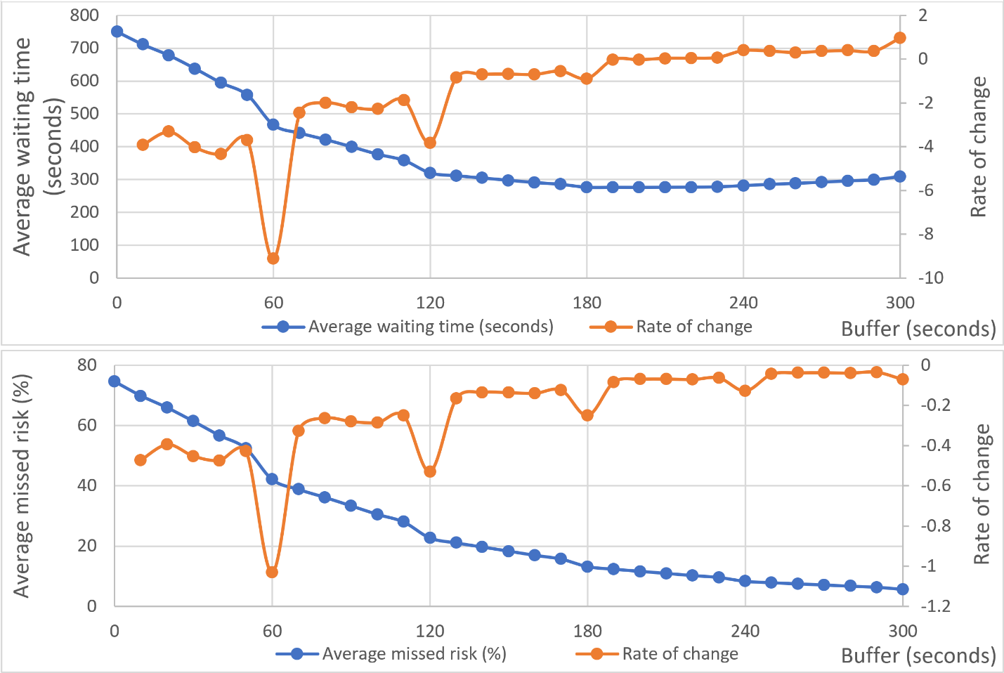

Figure 7: average waiting time/missed risk and their changing rates' relationship with the uniform buffer.

These results suggest that real-time information may have limited value with respect to minimizing waiting time and risk: the best RTI strategy (PT) is not substantially better than simply following the schedule (ST), and the RTI-based GT has the worst performance among all TPSs. However, note these are based on overall performance. The effectiveness of these strategies can vary with respect to time and space; we examine these patterns below.

* 1. **TPS performance over time**
     1. Hourly pattern

Figure 8 and Figure 9 illustrate the average waiting time and risk of missing a bus with respect to hour of the day. These hourly results support the overall results discussed above: ST and PT are consistently the best over the course of a day. AT, ET and GT perform especially poorly during service hours with long headways (6:00 to 8:00 and 21:00 to 24:00) since the time penalties associated with missing a bus during these periods are dramatically higher. These inferior strategies perform better during short headway hours, but not better than ST and PT. GT is a very risky strategy at all times, although is not penalized as harshly during short headway hours.

Although ST and PT are always competitive, although there are some differences in their performance over the day. For long headway hours in the morning and midnight, PT performs worse than ST; while for most hours during 8:00 to 21:00, performs PT almost the same as ST; especially, for afternoon hours from 17:00 to 20:00: with higher delay in the system due to peak traffic and user-related boarding delays, PT outperforms ST. In this sense, it is generally better for transit users to follow ST in the morning commuting and follow PT in the afternoon commuting. This suggests that PT is more sensitive to the headway and delays than ST.

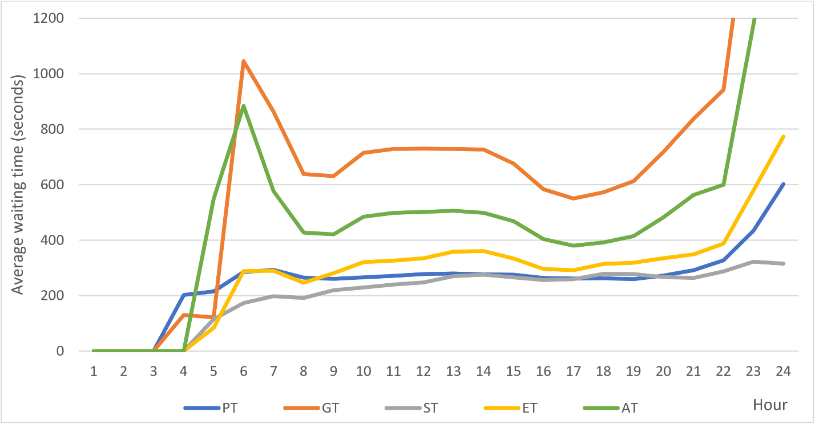

Figure 8: TPS average waiting time by hour of day.

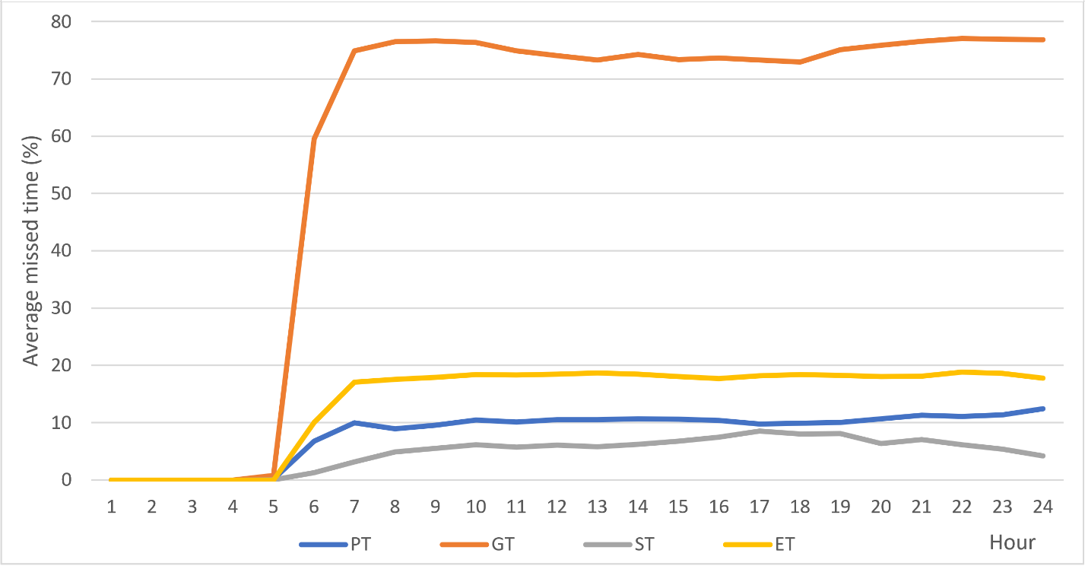

Figure 9: TPS risk of missed bus by hour of day.

* + 1. Service headway

As previous analyses suggest, headway is a crucial factor for the performance of TPSs. In this section, since different hour have a different headway for Route No.2 buses, we conducted two temporal analyses based on the average headway within each hour. The analyses suggest two empirical rules:

* The larger the headways are, the *more* effective PT compared to AT. This is obvious since AT’s waiting time is exactly the half of the headway. To moreover prove this, we investigated the correlation between the average waiting time difference in each hour and the average headway. The Pearson correlation coefficient is 0.9798 and the p-value is smaller than 0.0001. Figure 10 (left) shows the strong positive correlation between headway of each hour and the waiting time difference. Some former studies also suggested the same conclusion: in rural Scotland, RTI users can save 7 minutes in average (Papangelis et al. 2016), while in other studies in urban areas, the saved time is much less (Brakewood, Barbeau, and Watkins 2014; Chow, Block-Schachter, and Hickey 2014). RTI will flatten the radical waiting time difference between different systems caused by different scheduled frequencies.
* The larger the headways are, the *less* effective PT compared toST. Likewise, we tested the correlation between each hour’s average headway and corresponding performance difference. The Pearson correlation coefficient is -0.6201 and the p-value is 0.0012. Figure 10 (right) is the scatter plot of the two variables. The results show strong negative correlation between headway and the ST - PT waiting time difference.

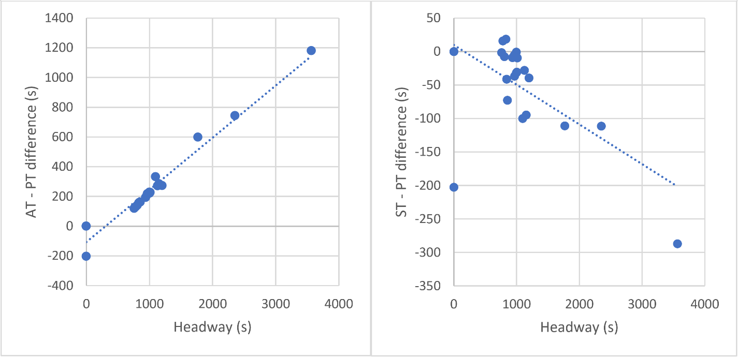

Figure : Scatter plots between headway and AT- PT (left side) and ST-PT (right side) waiting time differences.

* 1. **TPS performance over space**
     1. Walking time to bus stops

Figure 11 and Figure 12 illustrate the relationship between average waiting time and risk of missing a bus based on walking time from home to the closest stop. Again, we can see that the non-RTI strategy of following the schedule (ST) and the prudent RTI strategy (PT) are generally competitive with each other with respect to average waiting time. However, as walking time to the nearest bus stop increases, the PT waiting time increases relative to ST (Figure 12). The degradation of PT waiting time performance with increasing walk time is due to the increasing risk of missing a bus (Figure 13). This supports the claim that the longer distance a user lives from the stop, the more unstable their trip: the longer walking time to the stop, the bus has a greater chance to reclaim delay; because PT trips are synchronized to RTI, they are more sensitive to reclaimed/discontinuity delays. Therefore, PT users have a greater chance to desynchronize with longer walking time.

Interestingly, for the greedy strategy (GT), longer walking time lowers average waiting time since the missed risk decreases with distance from a stop. Similar to PT’s scenario, with longer walking time to the stop, the bus also has a greater chance to gain more delay; because GT trips are highly desynchronized due to a small reclaimed/discontinuity delay, the gained delay can offset the reclaimed/discontinuity delay, which plays a similar role as the insurance buffer. Therefore, GT users have a greater chance to resynchronize with longer walking time.

In conclusion, with longer walking distance/time, the chance of reclaiming and gaining delay will simultaneously increase while the chance of maintaining delay of the same value will decrease. PT and GT are the two polar of RTI-based TPSs and their performance will converge with longer walking time: highly synchronized PT is sensitive to reclaimed delay and its performance will become worse; while highly desynchronized GT is sensitive to gaining more delay and its performance will become better.

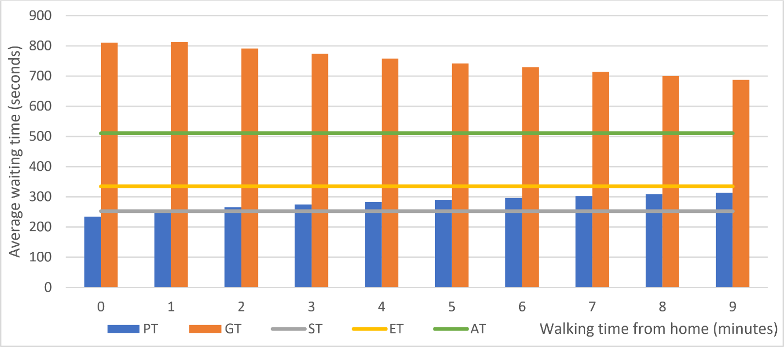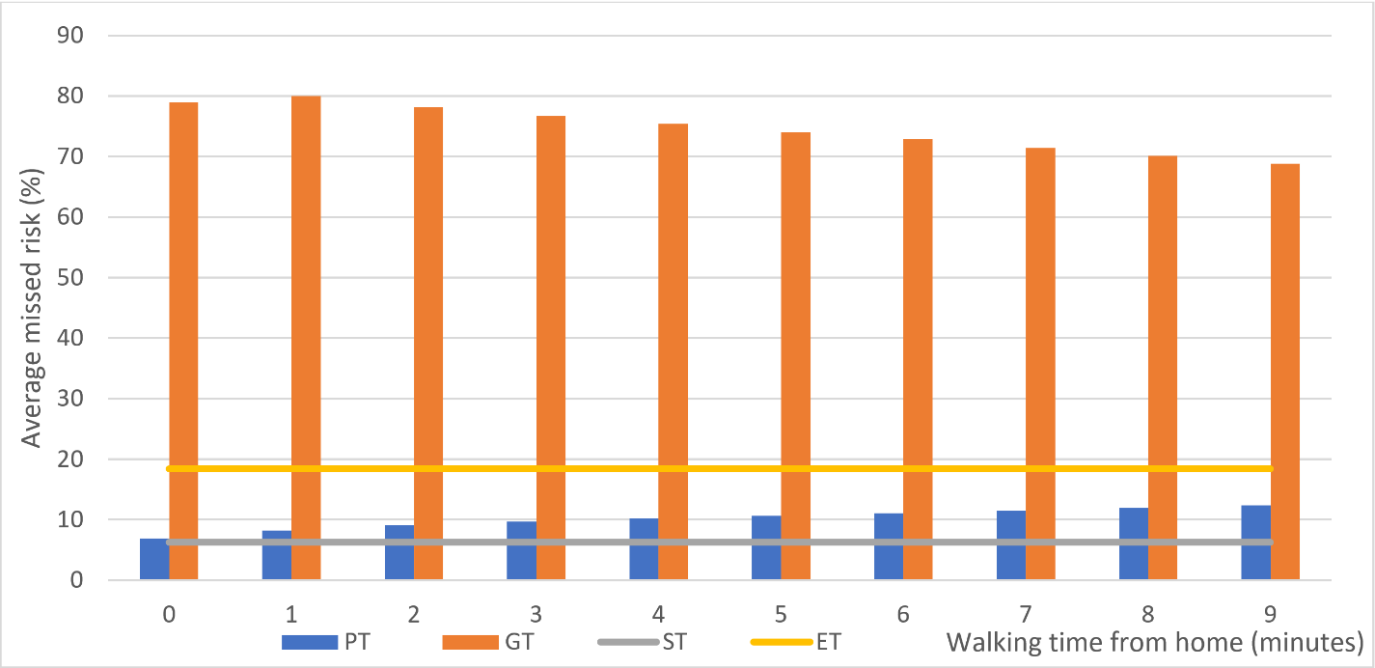

Figure 12: PT, GT, ET, and ST’s waiting time and missed bus risk's relationship with the walking time.

* + 1. Spatial patterns

As noted above, due to the heterogeneity of on-time performance over a bus route, the location of the bus stop within the route also influences the performance of a TPS. To illustrate this, we map the average wait time and risk of missing a bus for home locations within 0 – 9 minutes (0 – 756 meters) distance buffer of COTA bus route #2 heading from southwest to northeast, assuming users travel to their closest bus stop. Figure 13 and Figure 14 shows spatial pattern of waiting time and risk (respectively) for the AT, ST, ET, and GT strategies. These results confirm the waiting times are sensitive to the change in the headways (indicated by red ovals in the figures): with longer headways comes longer waiting times (Figure 13). In contrast, the risk of missing a bus does not increase dramatically with differences in headway frequency (Figure 14).

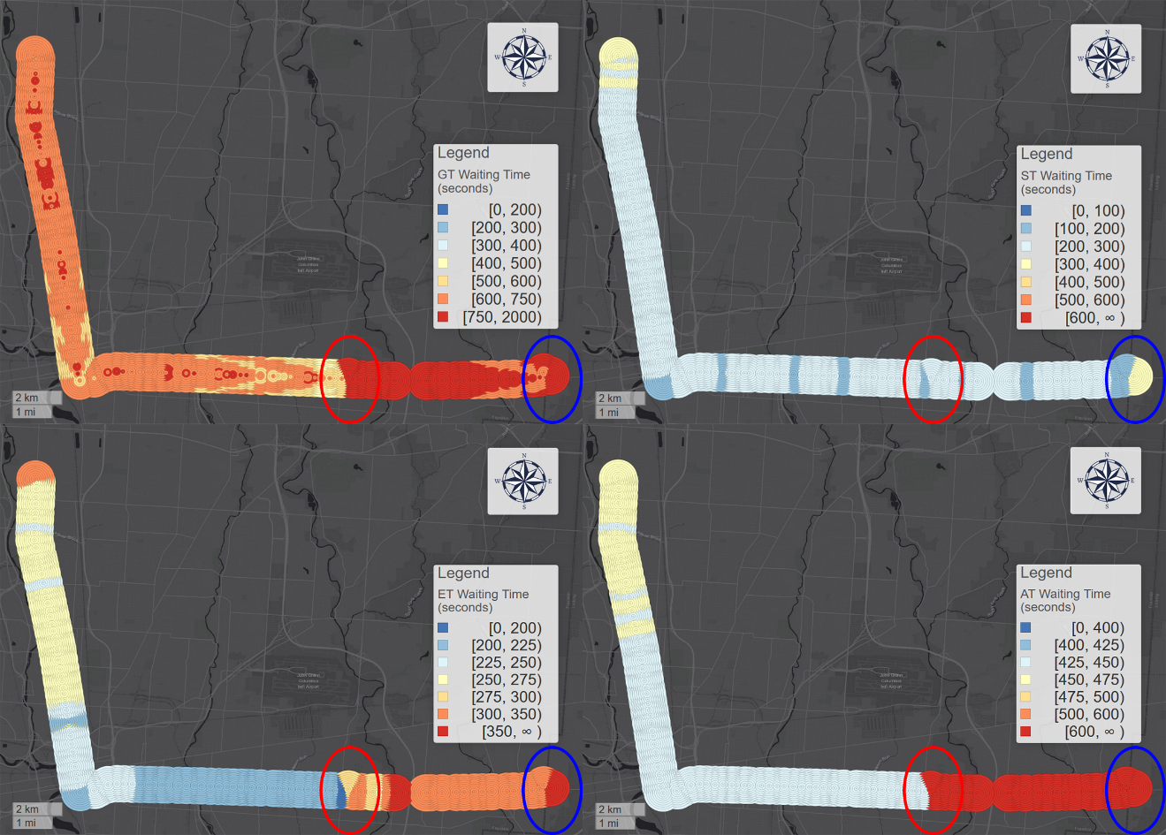

Figure 13: Spatial pattern of average waiting time within a walking distance buffer along the bus route: GT (top left), ST (top right), ET (bottom left), AT (bottom right)

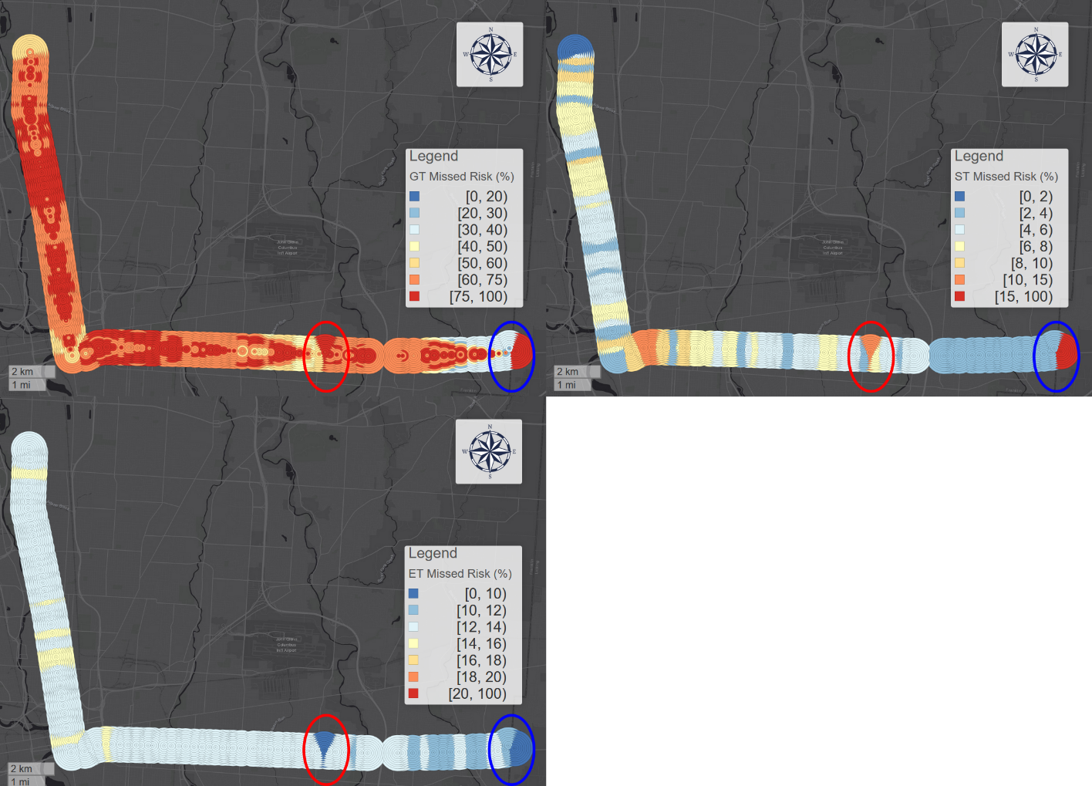

Figure 12: Spatial pattern of missed bus risk within a walking distance buffer along the bus route: GT (top left), ST (top right), ET (bottom)'s missed risk pattern.

Figure 15 shows the average waiting time and risk across space for the PT strategy. Noticeably, there are two significant clusters of high waiting time/high risk near the originating stops for standard headway service (indicated by a blue oval) and frequent headway service (indicated by the red oval). These clusters occur because real-time information will not be available for these stops until the bus leaves the originating stop. By the time the real-time information is updated, the user has likely missed the bus. Consequently, PT insurance buffer will not help improve the missed risk of such trips since its effectiveness depends on accessible RTI. Meanwhile, users who live far from the stop will have higher missed risk and will consequently suffer from even more waiting time. Based on these results, we can call these stops *marginalized stops*. It suggests that RTI strategies may be less effective at these stops. In these areas, transit users are vulnerable and may be structurally unable to utilize real-time information.



Figure : Spatial pattern of average wait time (left side) and missed bus risk (right side) within a walking distance buffer of the bus route for the PT strategy

* + 1. Spatial differences between ST and PT

We now compare the performance of best non-RTI strategy (ST) and best RTI strategy (PT) with respect to space. Figure 16 shows the average wait time difference between ST and PT within a walking distance buffer of the bus route. We observe the originating stops have exceptional high waiting time due to larger headway. We can also observe that PT does not outperform ST for more than half of all stops. In fact, for most stops, especially for those stops in the upstream near the originating stops, ST performance is much better than PT. To moreover demonstrate the variations, geographically, we divide the stops into two groups at stop “North High Street & Euclid Avenue” shown as a green line in Figure 16. For upstream stops, PT users waited 68 seconds more than ST users; while for downstream stops, ST users waited 21 seconds more than PT users. The comparison shows the highly polarized geographic pattern of relative performance between these two strategies.



Figure : PT – ST waiting time difference for each stop and walking time in COTA bus route No. 2 from Southeast to Northwest.

1. **Conclusion**

Previous research suggests that transit real-time information (RTI) can decrease transit users’ waiting time (Brakewood and Watkins 2019). However, few studies systematically investigate the mechanisms behind this claim and the variations across time and space of RTI impact on waiting time and the risk of missing a bus. In this paper, we theorize and validate the concept of reclaimed delay and discontinuity delay during the synchronization process between users and buses. We introduce the concept of trip planning strategy (TPS) and five types of TPSs for both RTI and non-RTI users. We calculate the empirical wait time and risk of the different TPS using real-time bus location data for a representative bus route in a mid-sized US city. We find that the best RTI strategy, a prudent tactic (PT) with an optimized insurance buffer, performs roughly the same as a simple, follow-the-schedule tactic (ST) that does not use RTI. The analyses results show that PT users in upstream stops on a route will wait more time than the ST users, and PT users in this area may suffer from higher risk of missing a bus than ST users. We also find that PT users are more advantageous during evening peak (17:00 – 20:00) than ST users. These results show that although the best RTI strategy can indeed save time for certain users in certain stops and during certain hours, they cannot globally outperform simply following the published schedule. Moreover, the greedy tactic (GT) of using RTI to achieve a waiting time of zero is the worst strategy, even worse than showing up at a bus stop arbitrarily. This suggests that RTI could make users’ waiting time significantly longer if apps are not using the appropriate trip planning strategy.

This study provides valuable insights for transit users, planners, and real-time transit app providers. With more access to real-time data, it is understandable that transit system navigation apps would engage with real-time performance data in addition to the published schedules. However, our results suggest that real-time performance data is not sufficient: RTI apps should also consider historical data to gauge the veracity of the RTI in reducing waiting time based on spatial and temporal context. Users should also have the option of specifying different TPS, including prudent strategies with insurance time buffers. At present, most RTI apps do not consider missed risk and implicitly promote a greedy strategy: as we have shown, this is a risky and poor performing strategy. The techniques and measure we develop in this paper can help support a more holistic and sensitive approach to public transit RTI apps.

To improve accuracy and reliability of RTI apps, transit authority or RTI apps providers can add pre-calculated insurance buffers based on stated or revealed risk attitudes of users. Also, our optimization of prudent tactic is not fully explored, there are likely better ways to find the optimal insurance buffer. Unlike simple non-RTI strategies that can be conceptualized and understood by humans from experience, RTI-based trip planning optimization can only be accomplished by the backend of the RTI apps, where more complicated and effective algorithms can be applied. Computational techniques such as machine learning and neural network could be applied to empirical performance and user data to determine effective trip planning strathies based on context and user risk preferences.

Finally, although individual passenger’s performance is systematically discussed in this paper, we do not empirically investigate or simulate the proportions of each user type as in as Jolliffe & Hutchinson (1975) and Bowman & Turnquist (1981). Future research should survey the different user groups and the way in which they use transit apps in their decision making so that RTI apps’ collective impact on the whole population could be understood.

Declarations of interest: none.

All figures are preferred to be printed with color.

Reference:

Algers, Staffan, Stein Hansen, and Goran Tegner. 1975. “Role of Waiting Time, Comfort, and Convenience in Modal Choice for Work Trip.” *Transportation Research Record* 534(534): 38–51.

Bowman, Larry A., and Mark A. Turnquist. 1981. “Service Frequency, Schedule Reliability and Passenger Wait Times at Transit Stops.” *Transportation Research Part A: General* 15(6): 465–71.

Brakewood, Candace et al. 2015. “An Analysis of Commuter Rail Real-Time Information in Boston.” *Journal of Public Transportation* 18(1): 1–20.

Brakewood, Candace, Sean Barbeau, and Kari Watkins. 2014. “An Experiment Evaluating the Impacts of Real-Time Transit Information on Bus Riders in Tampa, Florida.” *Transportation Research Part A: Policy and Practice* 69: 409–22.

Brakewood, Candace, and Kari Watkins. 2019. “A Literature Review of the Passenger Benefits of Real-Time Transit Information.” *Transport Reviews* 39(3): 327–56.

Cabannes, Theophile et al. 2018. “Measuring Regret in Routing: Assessing the Impact of Increased App Usage.” In *IEEE Conference on Intelligent Transportation Systems, Proceedings, ITSC*, IEEE, 2589–94.

Cats, Oded, and Zafeira Gkioulou. 2017. “Modeling the Impacts of Public Transport Reliability and Travel Information on Passengers’ Waiting-Time Uncertainty.” *EURO Journal on Transportation and Logistics* 6(3): 247–70.

Chow, William, David Block-Schachter, and Samuel Hickey. 2014. “Impacts of Real-Time Passenger Information Signs in Rail Stations at the Massachusetts Bay Transportation Authority.” *Transportation Research Record* 2419(1): 1–10.

COTA. 2013. “C. E. Main.” *Veterinary Record* 172(5): 134.1-134.

———. 2019. “How Does COTA Measure On-Time Performance?” https://www.cota.com/policies/on-time-performance/ (February 5, 2019).

Dutzik, Tony, Travis Madsen, and Phineas Baxandall. 2013. “A New Way to Go: The Transportation Apps and Vehicle-Sharing Tools That Are Giving More Americans the Freedom to Drive Less.” (Fall): 54.

Fan, Yingling, Andrew Guthrie, and David Levinson. 2016. “Waiting Time Perceptions at Transit Stops and Stations: Effects of Basic Amenities, Gender, and Security.” *Transportation Research Part A: Policy and Practice* 88: 251–64.

Ferris, Brian, Kari Watkins, and Alan Borning. 2010. “OneBusAway: Results from Providing Real-Time Arrival Information for Public Transit.” In *Conference on Human Factors in Computing Systems - Proceedings*, ACM, 1807–16.

Firmani, Donatella, Massimo Mecella, Monica Scannapieco, and Carlo Batini. 2016. “On the Meaningfulness of ‘Big Data Quality.’” *Data Science and Engineering* 1(1): 6–20.

Fonzone, Achille, Jan Dirk Schmöcker, and Ronghui Liu. 2015. “A Model of Bus Bunching under Reliability-Based Passenger Arrival Patterns.” *Transportation Research Procedia* 7: 276–99.

Fries, Ryan N., Anne E. Dunning, and Mashrur A. Chowdhury. 2011. “University Traveler Value of Potential Real-Time Transit Information.” *Journal of Public Transportation* 14(2): 29–50.

Gkioulou, Zafeira. 2013. “Evaluating the Impact of Waiting Time Uncertainty on Passengers´ Decisions.”

Google Developers. 2018. “Trip Updates.” https://developers.google.com/transit/gtfs-realtime/guides/trip-updates (April 8, 2019).

Jolliffe, J. K., and T. P. Hutchinson. 1975. “Behavioural Explanation of the Association between Bus and Passenger Arrivals at a Bus Stop.” *Transportation Science* 9(3): 248–82.

Larsen, Odd I., and Øyvind Sunde. 2008. “Waiting Time and the Role and Value of Information in Scheduled Transport.” *Research in Transportation Economics* 23(1): 41–52.

Liu, Luyu, and Harvey J. Miller. 2019. “Measuring Public Transit Transfer Risk Using High-Resolution Schedule and Real-Time Bus Location Data.” *Manuscript submitted for publication.*

Liu, Yang, Jing Shi, and Meiying Jian. 2017. “Understanding Visitors’ Responses to Intelligent Transportation System in a Tourist City with a Mixed Ranked Logit Model.” *Journal of Advanced Transportation* 2017.

Mishalani, Rabi, Mark McCord, and John Wirtz. 2006. “Passenger Wait Time Perceptions at Bus Stops: Empirical Results and Impact on Evaluating Real - Time Bus Arrival Information.” *Journal of Public Transportation* 9(2): 89–106.

Neuman, W. L., & Robson, K. 2004. *“Basics of Social Research. Pearson.”* Pearson Canada Toronto.

Papangelis, Konstantinos, John D. Nelson, Somayajulu Sripada, and Mark Beecroft. 2016. “The Effects of Mobile Real-Time Information on Rural Passengers.” *Transportation Planning and Technology* 39(1): 97–114.

Park, Yongha et al. 2019. “Assessing Public Transit Performance Using Real-Time Data: Spatiotemporal Patterns of Bus Operation Delays in Columbus, Ohio, USA.” *International Journal of Geographical Information Science*: 1–26.

Reed, Thomas B. 1995. “Reduction in the Burden of Waiting for Public Transit Due to Real-Time Schedule Information: A Conjoint Analysis Study.” In *Vehicle Navigation and Information Systems Conference (VNIS)*, IEEE, 83–89.

Transit app. 2019. “How We Shrank Our Trip Planner till It Didn’t Need Data. Introducing Public Transit’s Fastest, Tiniest, Offline-Capable Trip Planner.” https://medium.com/transit-app/how-we-shrank-our-trip-planner-till-it-didnt-need-data-84984ca56663 (December 5, 2019).

Walker, Jarrett. 2012. Human Transit: How Clearer Thinking About Public Transit can Enrich our Communities and our Lives *Human Transit: How Clearer Thinking about Public Transit Can Enrich Our Communities and Our Lives*. Island Press.

Watkins, Kari Edison et al. 2011. “Where Is My Bus? Impact of Mobile Real-Time Information on the Perceived and Actual Wait Time of Transit Riders.” *Transportation Research Part A: Policy and Practice* 45(8): 839–48.

1. * Corresponding author email: [miller.81@osu.edu](mailto:miller.81@osu.edu). Permanent address: 154 N Oval Mall, Columbus, OH 43210